Hands-on 5: Mastering Concurrency

1. Prerequisites
- Terminal Access: Open your VS Code terminal.
- Basic Knowledge: Understanding of functions and loops (from Module 1 & 2).

2. Why are we doing this?
In modern computing, we don't want to wait for one task to finish before starting the next. Whether it's processing thousands of bank transactions or scraping multiple websites, Go’s concurrency model allows you to run thousands of tasks simultaneously using very little memory.

3. Objective
- Launch background tasks using the go keyword.
- Use Channels to move data between Goroutines.
- Orchestrate multiple tasks using WaitGroups.
- Implement a Select statement to handle multiple data streams.
- Mini-Project: Build a Concurrent Web Scraper that "pings" multiple URLs at once.

4. Steps To Follow

Step 1: Launching Goroutines
Create goroutines.go. We will see how the go keyword prevents a function from "blocking" the rest of the program.
package main
import (
"fmt"
"time"
)
func displayMessage(text string) {
for i := 1; i <= 3; i++ {
fmt.Printf("%s: %d\n", text, i)
time.Sleep(100 * time.Millisecond)
}
}
func main() {
// Start this as a background task
go displayMessage("Background Task")
// This runs immediately without waiting
displayMessage("Main Task")
fmt.Println("Program Finished.")
}

Run command:
go run goroutines.go

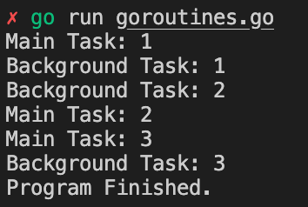

Step 2: Channels & Select
Create channels_select.go. Channels are pipes that connect goroutines. The select statement acts like a switch for channels.
package main
import (
"fmt"
"time"
)
func server1(ch chan string) {
time.Sleep(1 * time.Second)
ch <- "Response from Server 1"
}
func server2(ch chan string) {
time.Sleep(2 * time.Second)
ch <- "Response from Server 2"
}
func main() {
chan1 := make(chan string)
chan2 := make(chan string)
go server1(chan1)
go server2(chan2)
// Select waits for the FIRST channel that is ready
for i := 0; i < 2; i++ {
select {
case msg1 := <-chan1:
fmt.Println(msg1)
case msg2 := <-chan2:
fmt.Println(msg2)
}
}
}

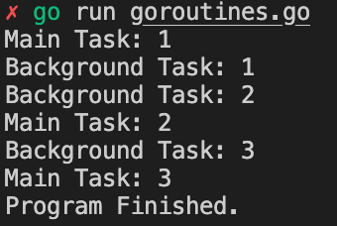

Step 3: Synchronization with WaitGroup
Create waitgroup.go. Sometimes you need the main function to wait until all background work is finished.
package main
import (
"fmt"
"sync"
)
func worker(id int, wg *sync.WaitGroup) {
defer wg.Done() // Tells the WaitGroup this task is finished
fmt.Printf("Worker %d is processing data...\n", id)
}
func main() {
var wg sync.WaitGroup
for i := 1; i <= 5; i++ {
wg.Add(1) // Increment the counter for each task
go worker(i, &wg)
}
wg.Wait() // Blocks here until the counter reaches zero
fmt.Println("All workers finished. Closing program.")
}

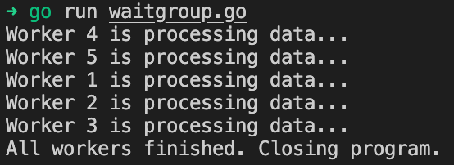

5. Mini-Project: Concurrent "Web Scraper" Simulator
Create scraper.go. Real web scraping requires external libraries, so we will simulate the "ping" process. This program will check 3 URLs at the same time rather than one-by-one.
package main
import (
"fmt"
"net/http"
"sync"
"time"
)
func checkURL(url string, wg *sync.WaitGroup, results chan string) {
defer wg.Done()
start := time.Now()
resp, err := http.Get(url)
if err != nil {
results <- fmt.Sprintf("[ERROR] %s is down!", url)
return
}
defer resp.Body.Close()
elapsed := time.Since(start).Seconds()
results <- fmt.Sprintf("[SUCCESS] %s returned %d in %.2fs", url, resp.StatusCode, elapsed)
}
func main() {
urls := []string{
"https://google.com",
"https://github.com",
"https://go.dev",
}
var wg sync.WaitGroup
results := make(chan string, len(urls))
fmt.Println("Starting Concurrent Scraper...")
for _, url := range urls {
wg.Add(1)
go checkURL(url, &wg, results)
}
// Wait for all pings to finish in a separate goroutine
go func() {
wg.Wait()
close(results) // Close the channel when work is done
}()
// Print results as they arrive
for res := range results {
fmt.Println(res)
}
fmt.Println("Scraping Complete!")
}

Run command:
go run scraper.go

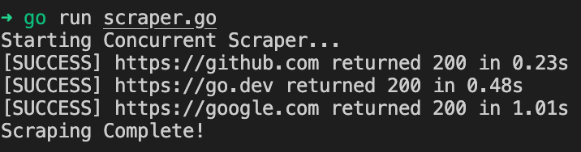

6. Checklist of Accomplishments
- [ ] Goroutines: Used the go keyword to run tasks non-blockingly.
- [ ] Channels: Sent and received data between functions safely.
- [ ] WaitGroups: Synchronized the main thread with background workers.
- [ ] Select: Handled multiple channel responses.
- [ ] Mini-Project: Built a parallel system that interacts with real web servers.

7. Conclusion
You have mastered the hardest part of Go! Concurrency is what separates "scripts" from "systems." You now know how to run tasks in parallel, communicate between them, and ensure your program waits for everyone to finish. This is the foundation for building high-performance APIs and cloud tools.

CONGRATS!
You have officially completed the Go Basic Hands-on Roadmap!
Final Steps for you: Try adding a fake/broken URL to the scraper.go list to see how it handles errors.

